Grade 7 Accelerated · Unit 3 · Thread A · Day 2  Negative Exponents with Variable Bases  Independent Set 3.T2 | Name______________________  Date______________________  Period____________________

Six questions, on your own, in silence. Show the step that does the work.
1. Rewrite using only positive exponents. 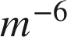

2. Rewrite using only positive exponents. 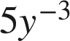

3. Rewrite using only positive exponents. 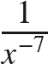

4. Simplify. Use positive exponents only. 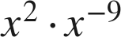

5. Simplify. Use positive exponents only. 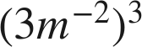

6. Find the value of . 